Chapter 4

Experimental Methods

Introduction
Various experimental techniques were used in this work for the fabrication, processing and characterising of devices. This Chapter describes the deposition techniques used to fabricate the cells in Section 4.2. Following that, in Section 4.3.1, a detailed description of the typical fabrication steps for device production is presented. Section 4.3.2 discusses special processing procedures employed in this work. Finally, analytical techniques by which the devices were investigated are described in Section 4.4.

Deposition Techniques

Chemical bath deposition (CBD)
Chemical bath deposition (CBD) relies on a chemical reaction taking place in a solution in which substrates are immersed. Various semiconductor materials have been successfully deposited by CBD such as CdO [1], Bi₂O₃ [2] and ZnS [3]. CBD has several advantages such as simplicity and low cost. However, the large amount of the liquid waste of CBD can be problematic, especially if the waste contains poisonous materials.
This work includes samples incorporating CdS films grown by CBD. The properties of the CBD-CdS principally depends on the growth conditions such as the recipe of the reacting chemicals [4] and the deposition temperature [5]. There are numerous recipes in the literature, however, the recipe used in this work was the standard one commonly used at Cranfield University [6]. A deposition solution containing CdCl₂ (0.0024M), NH₄Cl (0.028M) and CSN₂H₄ (0.057M) was diluted in DI water and contained in a water-jacket beaker, which was itself placed in an ultrasonic bath. The total volume of the solution was 500 ml. Figure ‎4.1 illustrates a schematic diagram of the apparatus used for the CBD-CdS deposition.

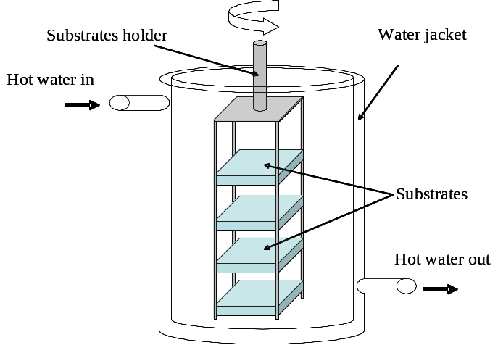

Figure ‎4.1: A schematic diagram of the apparatus used for depositing CdS by the CBD technique.

After cleaning the substrates (see Section 4.3.1) they were placed in a quartz holder prior to immersion in the solution. The holder (Figure ‎4.1) held up to four 5×5 cm substrates for simultaneous deposition. The deposition temperature was kept at ~ 70°C and controlled by circulating hot water in the water-jacket beaker. When the temperature of the solution reached ~ 70°C, 28 ml of 35% NH₃ solution was added to it, which started the deposition. During the whole process, the solution was stirred by rotating the holder by means of a small electrical motor. The deposition time was ~ 15 minutes and resulted in 150-200 nm thick CdS films.

Close space sublimation (CSS)
Physical Vapour Deposition (PVD) techniques are used to deposit thin films in vacuum by vaporising the material by physical mechanisms such as heating. Close space sublimation is a PVD technique where deposition takes place by sublimation. Since it is difficult to evaporate materials with high melting point, sublimation represents a suitable alternative as it takes place at lower temperatures. CdTe (melting point = 1365°C [7]) is widely deposited by this technique since its vapour pressure is ~ 0.1 Torr at 600°C, which is one order of magnitude larger than the estimated vapour pressure required to generate functional condensation rates [8]. However, the separation between the source material and the substrate is therefore much shorter in the CSS technique compared to standard evaporation one in order to reduce the vapour loss.

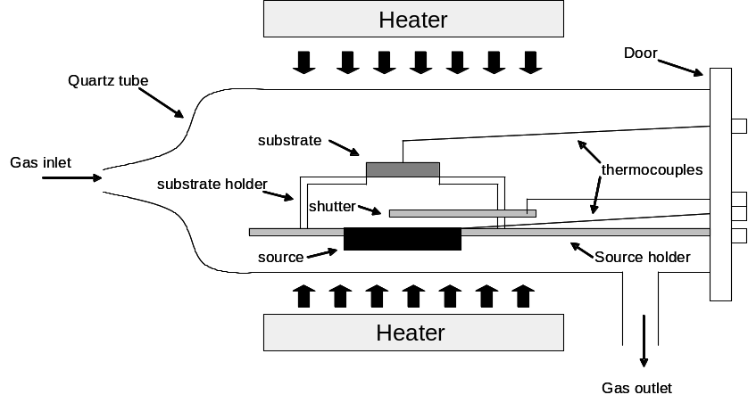

Figure ‎4.2: A schematic diagram of the CSS reactor.

The CSS kit used in this work was built by Electro Gas System Ltd. Figure ‎4.2 shows a schematic diagram of the reactor in this kit. The tube and the furniture inside are made from quartz to minimise the inclusion of impurities. The separation between the substrate and the source material is ~ 12 mm. There are two thermocouples inside the reactor: one touches the tray of the source material and the other touches the substrate. Heating is provided by two separate heaters (upper and lower), each with a separate temperature control. Various gases such as O₂, N₂ and H₂ can be introduced into the reactor. The chamber pressure is controlled by both automatic and manual valves placed between the reactor and a scroll pump.
A separate but identical reactor is used for each material deposition i.e. CdTe and CdS. The source materials for both cases are supplied by Alfa Aesar as powder with purity of 5N. A variety of gaseous ambients and growth conditions (e.g. temperature and time) were used throughout this work. Specific details for each growth run are given in the appropriate chapter.

Sputtering
Like the CSS process, sputtering is a PVD technique since deposition happens by vaporising the source material. However, the deposition takes place in this technique by ejecting atoms from the target material by bombarding it with energetic ions. Those sputtered atoms then condense on the surfaces of the surrounding objects e.g. substrates. Electric and magnetic fields are used in sputtering process so that a) the ions gain enough kinetic energy, and b) they can be aimed to the target. Because sputtering is a mechanical technique, it is capable of depositing any material [8].
Sputtering types are categorised based on the applied electric field between the target and the substrate into: a) DC, and b) RF (radio frequency). The DC type is suitable for sputtering only conductive materials, due to charge accumulation on the surface of non-conductive materials. This issue may be overcome by using RF sputtering instead [9].
AJA International, Inc. ATC ORION sputtering systems were used to deposit different materials in this work, with the sputtering targets also being supplied by AJA.
The study concerning devices fabricated with sputtered CdS is presented in Section 4.3.2.1. Those CdS films were sputtered from a 5N pure CdS target at room temperature with an RF power of 200 W. The total pressure in the chamber was 5 mTorr provided by an O₂/Ar mix with a 5 % O₂ concentration. The deposition time was 16.5 minutes, and the thickness of the films was ~ 200 nm as measured by an Ambios XP 200 profiler (see Section 4.4.4 for details of thickness measurement).

Metal organic chemical vapour deposition (MOCVD)
This technique is a specific kind of chemical vapour deposition (CVD) [10]. The required chemicals are admitted to the deposition chamber in the vapour phase, then react near a heated substrate [11]. Since the deposition is chemical (i.e. due to chemical reaction), it is not a vacuum technique. CdTe and CdS layers grown by MOCVD in this thesis were fabricated at Bangor University. The precursors used for CdTe growth were dimethylcadmium (DMCd) and diisopropyltelluride (DIPTe) while they were dimethylcadmium (DMCd) and ditertiarybutylsulphide (DTBS) for CdS. For these devices, the CdCl₂ treatment was applied in-situ by MOCVD, using Dimethylcadmium (DMCd) and tertiarybutylchloride (tBuCl) or n-hexylchloride (n-HexCl) alkyl precursors. More detailed description about the deposition procedures is reported by Barrioz et el. [12-14].

Thermal evaporation
Thermal evaporation is another kind of PVD techniques, and it is commonly used for depositing thin films. It is the most effective method to deposit materials with low melting points [8].This technique is similar to CSS in the sense that deposition relies on heating the source material under vacuum. However, in thermal evaporation the vaporisation happens from a liquid phase, whereas in CSS it occurs from a solid phase. As the vapour pressure is much grater than for CSS deposition, the separation between the substrate and the source could be few tens of centimetres.
Thermal evaporation was used to deposit three materials in this work: CdCl₂, In and Au.

CdCl₂
The evaporator used to deposit this material is custom made, and consisted of a single chamber connected to both rotary and diffusion pumps. Deposition took place at a pressure of ~ 10⁻⁵ Torr, with the deposited thickness being in-situ monitored. The source material was a powder with purity of 4N supplied by Aldrich.

In
Evaporation of In was similar to that of CdCl₂ but in a separate evaporator. However, there was no thickness monitoring during In deposition.

Au
Au was deposited by UNIVEX 300 evaporator at a pressure of ~ 10⁻⁵ Torr. The Au was 6N pure and supplied by Advent. Various masks were custom made and used for contacting samples. The thickness of the deposited films was in-situ monitored.

Device Fabrication and Material Processing

Device fabrication steps
Prior to CdS deposition, substrates were cleaned in the following sequence:
a) Cleaning the TCO substrates.
  - Rubbing each plate by tissues saturated with Decon90 soap solution.
  - Rinsing thoroughly by DI water.
  - Soaking in Decon90 soap solution combined with ultrasonication for 30 minutes.
  - Rinsing thoroughly by DI water.
  - Soaking in acetone combined with ultrasonication for 15 minutes.
  - Soaking in iso-propanol combined with ultrasonication for 15 minutes.
  - Drying with dry N₂.

b) Growth of the CdS
CdS films were grown by either CBD, sputtering, CSS or MOCVD see Section 4.2 for more details.

c) Optional post-growth treatment of the CdS
The typical treatment for the CdS performed in the device fabrication was post-growth annealing in H₂ ambient in the CdTe CSS reactor. However, for investigations of the CdS/TCO bilayer (Chapter 5), CdS annealing was also performed in either O₂ or N₂. Heating was provided by either the upper of the lower heater. Details of annealing conditions (e.g. time and temperature) are given for each experiment specifically in later chapters.

d) Growth of the CdTe
The growth of the CdTe was undertaken by either CSS or MOCVD, see Section 4.2 for details.

e) Chloride treatment
Deposition
The treatment was applied by thermal evaporation of CdCl₂ layers on the back surface of the CdTe, see Section 4.2.5 for details.

Annealing
After applying the CdCl₂, all samples were annealed in air using a tube furnace. The samples were placed on a silicon wafer held on a quartz frame. The duration of annealing started when the sample was put in the middle of the furnace, and ended when it removed to the edge of the furnace tube. A range of temperatures and annealing times were used in this work, specific details are given in the relevant chapters.

Cleaning
Following annealing, all samples were washed by hot DI water to remove any excess amount of CdCl₂ left after treatment. Next, the samples were washed thoroughly by DI water prior to drying by a flow of N₂.

f) Preparation of the CdTe surface for back contacting
In the case of this work different etching techniques were used to prepare the back surface of devices for contacting. The procedure of each technique is described in this Section. However, a detailed study and particular methods used for these kinds of etching are presented in Chapter 7.

i) N-P etching
N-P etching is a typical processing step for fabricating devices. It was used with most of cells investigated in this work. The steps of etching are as following:
- Each sample was etched in a solution comprising 70 % H₃PO₄, 29 % H₂O and 1 % HNO₃ [15] for 10 seconds, with timing being started from immersion in the solution.
- Rinsed thoroughly by DI water,
- Dry by flowing N₂,

ii) Plasma etching
This process was performed in the sputtering system using an Ar⁺ plasma. Etching was performed at room temperature under a pressure of 10 mTorr of Ar using a DC power of 25 W. The etching rate of the conditions described above was ~ 7 nm/minute.

g) Contacting deposition
Different materials applied by different deposition techniques were used to contact samples investigated in this work, as described below.

i) Thermal evaporation
Au contacts were always applied by thermal evaporation, see Section 4.2.5. Similarly, In contacting (for the CdS/TCO bilayer study in Chapter 5) was done by this technique as well.

ii) Sputtering
In Chapter 7, besides using Au, either As₂Te₃ or Sb₂Te₃ were DC sputtered as back contacts for the devices. The deposition conditions for both As₂Te₃ and Sb₂Te₃ were similar and as follows: DC power was 25 watts with a chamber pressure of 5 mTorr (pure Ar). The deposition time was 30 minutes at temperature of 300°C, resulting in a 100 nm thick film. Subsequently, both materials were covered by a layer of 200 nm Mo sputtered by: 100 watts (DC) at 5 mTorr pressure (Ar) for 25 minutes at 300°C.

Materials processing steps for special studies (bevel etching)
The bevel etching of CdTe cells was undertaken in order to prepare cells for rapid screening experiments (see Section 5.3).

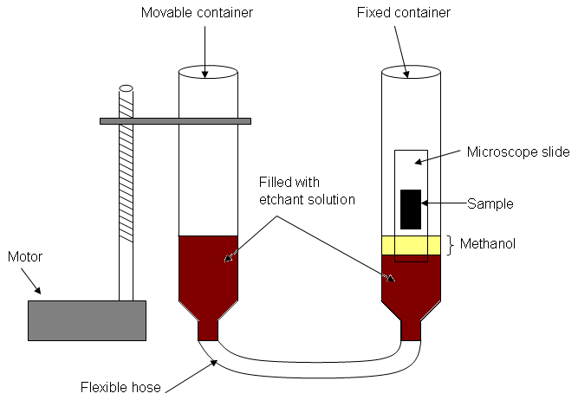

Figure ‎4.3: A schematic diagram of the bevelling apparatus.

Figure ‎4.3 shows a schematic diagram of the apparatus used for bevelling the samples, with the bevelling process being as follows. Each sample was attached to a microscope slide by wax prior to etching. Next, bevelling was done by immersing the sample at a speed of 2 mm/min into a solution comprising 4.5% bromine, 25.5% methanol and 70% ethylene glycol (by volume). Immersion rate was controlled by means of an apparatus comprising two containers connected by a flexible tube. The sample was fixed in one, and the level of the liquid was controlled by moving the other by means of a lead screw driven by a slow motor. There was ~ 1 cm thick layer of pure methanol on top of the etchant solution in the container holding the sample, this is shown in Figure ‎4.3. The reason of it was to protect the sample from being etched due to the etchant solution vapour [16]. Figure ‎4.4 illustrates a complete CdTe/CdS cells before and after bevelling and contacting. Details of the order of bevelling, CdCl₂ treatment and contacting may be found in Section 5.3.

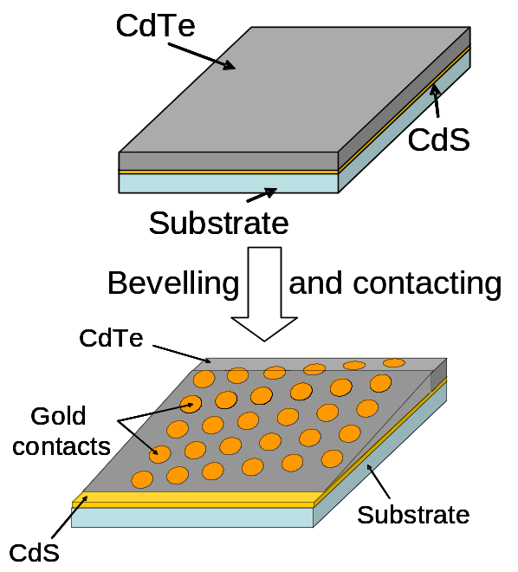

Figure ‎4.4: CdTe/CdS sample before (upper) and after (lower) bevelling and contacting.

Characterisation methods

J-V characterisation
The J-V measurements were carried out in this work by applying a voltage across the device terminals using Keithley 2400 source meter, which also measured the resultant current. The J-V data were fed into a Labview programme in order to determine the basic PV working parameters i.e. η, FF, V_{oc} and J_{sc}.
The J-V measurements were done in both dark or under light. An Oriel 81160 solar simulator was used to provide the AM1.5 illumination for light measurements (see Section 1.3.1 for more details about the AM1.5 spectrum).

J-V-T characterisation
In this method a family of J-V curves are recorded for a range of temperature (T). The same setup described in the previous Section was used for this measurement. However, in order to perform the J-V characterisation at different T, the samples were mounted inside a cryostat chamber. The cryostat system is consisted of a CTI Cryogen Refrigerator supplied by Helix Technology Corporation, and a LakeShore331 temperature controller.
J-V-T measurements were performed in both dark and at various light intensities. Figure ‎4.5 illustrates a set of mirrors used to deflect light from the solar simulator into the cryostat chamber. The light intensity was controlled by covering the cryostat window with natural density (ND) optical filters.

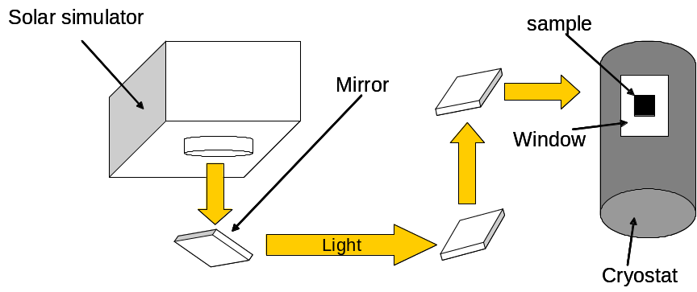

Figure ‎4.5: A schematic diagram showing the setup used to deflect the light from the solar simulator into the cryostat for J-V-T measurements.

Quantum efficiency
The quantum efficiency (QE) of a solar cell is defined as the ratio of the collected light-generated electrons to the incident light [17]. It therefore measures the probability of generating an electron from each incident photon [18]. There are two kinds of QE: a) external quantum efficiency (EQE) which is the ratio of the collected photocurrent to the total incident light [17], and b) internal quantum efficiency (IQE), which is the same as EQE except that only the absorbed light is considered (i.e. losses in light such as reflection and transmission are not considered in the measurements) [17].
Each layer of the cell contributes to the results of the EQE. For example, Figure ‎4.6a shows the ideal EQE response for a CdS/CdTe cell. The square shape of the EQE curve (as shown in Figure ‎4.6a) is obtained if both the CdS and the CdTe are thick enough and if the junction is located in the right position i.e. at the interface between these two materials. Photons with energy > CdS E_{g} are absorbed in the CdS layer, thus they do not participate in the current. Similarly, photons with energy < CdTe E_{g} will not be absorbed by either CdS or CdTe, and hence they do not generate carriers. Only photons having energies < CdS E_{g} and > CdTe E_{g} can generate current and hence contribute to the EQE signal.

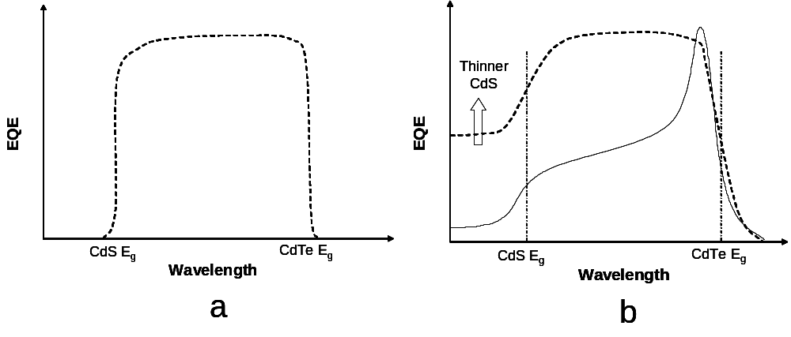
Figure ‎4.6: a) a schematic diagram of an idealised EQE curve for CdS/CdTe cells. b) the dashed line shows the typical EQE for the CdS/CdTe cells whereas the solid line shoes the EQE of a buried junction.

It is seen in Figure ‎4.6b that if the CdS is thin enough, it partially allows photons with energy > CdS E_{g} to pass though it, as CdS is not capable to absorb all of them. Those photons are absorbed in the CdTe, and therefore generate current. This behaviour will raise the EQE curve near the CdS cut-off, as seen in Figure ‎4.6b. In the case of having a buried homojunction (i.e. a homojunction within the bulk of the CdTe), the EQE will have the shape shown by the solid line in Figure ‎4.6b. The loss in current in this case is due to the generation of the carriers in regions near the homojunction, which is not located at the CdTe/CdS interface. There is therefore no sweeping of the carriers to the external circuit [11].
The EQE measurements in this work have been performed by the author at Glyndŵr University, using a PVE300 photovoltaic spectral response kit supplied by Bentham.

Film thickness measurement
An Ambios XP 200 profiler was used to measure the thickness of the deposited films. In case of CdTe, the film was scribed by a scalpel prior to measuring the depth of the resultant grove i.e. the CdTe thickness. On the other hand, as it is hard to create a grove on the CdS films by scribing, a cotton bud saturated with HCl was used to wipe off part of the CdS film. The profiler determined CdS thickness by measuring the height difference between the CdS and the revealed substrate. Figure ‎4.7 illustrates the grove in a layer scanned by the profiler in order to determine the thickness.

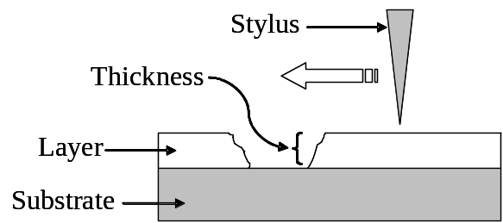

Figure ‎4.7: thickness measurement of a thin film.

Compositional analysis techniques

Secondary ion mass spectroscopy (SIMS)
This is a destructive technique used to probe the composition of material surfaces. It sputters the surface of the investigated sample by a focused primary ion beam (see Section 4.2.3 for more details about sputtering). The sputtered secondary ions are then detected and analysed based on their mass/charge ratio [19]. The primary ions not only eject the secondary ions but also remove layers of the surface, resulting in a crater. As the primary ions continue bombarding, they sputter and probe the new revealed layer of the sample. Therefore, depth profiles of the sample composition can be determined. The depth resolution of SIMS can be as shallow as 5 – 10 nm [20].

Auger electron spectroscopy (AES)
This characterising technique based on the Auger effect. If a core electron is sufficiently excited to create a core hole, another electron from an outer shell will recombine with this hole. The recombination results in an X-ray photon which is capable to eject a second electron from the same atom. This emitted electron is called Auger electron, which is a characteristic of the atom.
In AES a primary electron beam is used to emit Auger electrons from the sample. Those ejected electrons are detected and used to identify the elements of the sample. Auger technique can be combined with sputtering so that a compositional depth profile of the sample is obtained [21]. Since the escape depth of Auger electrons is short [20], the surface sensitivity of AES is extreme. Therefore it is a powerful tool to investigate surfaces.
In this work both SIMS and AES runs were performed and analysed in Loughborough Surface Analysis Ltd.

Grazing incidence X-ray diffraction (GIXRD)
This is a special kind of X-ray diffraction technique (XRD). In standard XRD, the samples are investigated by shining X-ray beams into them and detecting the scattered (diffracted) resulted beams. According to Bragg’s law, if the lattice planes (formed by the atoms in the crystal) are perfect and spaced from each other by a distance d as shown in Figure ‎4.8, then the “reflection” of a monochromatic beam takes place only at a certain angle which satisfies the following equation [22]

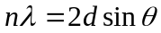 (‎4.1)

where n = 1, 2, 3 … etc,  is the wavelength of the beam and  is the incidence angle (and the reflection angle too as reflection is assumed to be elastic). Equation 4.1 implies that by using a monochromatic X-ray (with a known wavelength) and detecting the diffraction angles, d values can be calculated. These data are then compared to the standard values to probe the crystalinity and the composition of the material.

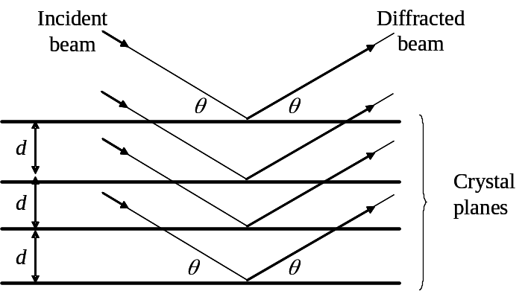

Figure ‎4.8: A perfect crystal with incident and diffracted beams. d is the spacing between each two adjacent planes and  represents both incident and diffracted angles.

In GIXRD, the incident angle is chosen to be very small, which results in shallow penetration into the material. Therefore, the diffracted beams give information about the surface rather than the bulk. The surface sensitivity can be increased by further reducing the incidence angle [23].
The GIXRD runs in Section 4.2.3 were carried out in Durham University by another research group.

References for Chapter 3
[1] D. S. Dhawale, A. M. More, S. S. Latthe, K. Y. Rajpure and C. D. Lokhande, Applied Surface Science 254 (2008) 3269-3273.
[2] T. P. Gujar, V. R. Shinde, C. D. Lokhande, R. S. Mane and S. Han, Applied Surface Science 250 (2005) 161-167.
[3] T. Nakada, M. Hongo and E. Hayashi, Thin Solid Films 431-432 (2003) 242-248.
[4] S. Prabahar and M. Dhanam, Journal of Crystal Growth 285 (2005) 41-48.
[5] L. Wenyi, C. Xun, C. Qiulong and Z. Zhibin, Materials Letters 59 (2005) 1-5.
[6] U. S. Ketipearachchi, D. W. Lane, K. D. Rogers, J. D. Painter and M. A. Cousins, Materials for Photovoltaics 836 (2005) 161-166.
[7] L. I. Berger and B. R. Pamplin. in (D. R. Lide and H. P. R. Frederikes, eds.) CRC Press LLC (1997-1998).
[8] J. A. Thornton. in (G. E. McGurie, Ed.) Semiconductor Materials and Process Technology Handbook, Noyes Publications, New Jersey (1988).
[9] J. A. Thornton and J. E. Greene, Handbook of deposition technologies for films and coatings : science, technology and applications, 2nd ed., Noyes Publications, New Jersey, (1994).
[10] G. Zoppi, PhD Thesis, Durham University, Durham, (2005).
[11] J. Major, PhD Thesis, Durham University, Durham, (2008).
[12] V. Barrioz, S. J. C. Irvine, E. W. Jones, R. L. Rowlands and D. A. Lamb, Thin Solid Films 515 (2007) 5808-5813.
[13] V. Barrioz, R. L. Rowlands, E. W. Jones, S. J.C. Irvine, G. Zoppi and K. Durose, in Thin-Film Compound Semiconductor Photovoltaics, Warrendale, PA, USA, (2005), 865, 67-72.
[14] V. Barrioz, Y. Y. Proskuryakov, E. W. Jones, J. D. Major, S. J.C. Irvine, K. Durose and D. A. Lamb, in Materials Research Society, Spring meeting, Symposium Y, San Francisco, CA, USA, (2007), 1012, 367-372.
[15] M. Hadrich, N. Lorenz, H. Metzner, U. Reislohner, S. Mack, M. Gossla and W. Witthuhn, Thin Solid Films 515 (2007) 5804-5807.
[16] M. A. Cousins, PhD Thesis, Durham University, Durham, (2001).
[17] Alan L. Fahrenbruch and Richard H. Bube, Fundamentals of Solar Cells, 1st ed., Academic Press, London, (1983).
[18] J. Nelson, The Physics of Solar Cells, 2nd ed., Imperial College Press, London, (2003).
[19] A. E. Morgan. in (McGurie, G.E., Ed.) Characterization of Semiconductor Materials Principles and Methods, Noyes Publication, New Jersey (1989).
[20] D. Schroder, Semiconductor Material and Device Characterization, Third Edition ed., John Wiley & Sons (2006).
[21] G. E. McGurie. in (G. E. McGurie, Ed.) Semiconductor Materials and Process Technology Handbook, Noyes Publications, New Jersey (1988).
[22] H. S. Lipson, Crystals and X-rays, Wykeham Publications Ltd, London, (1970).
[23] P. Dutta, Current Science 78 (2000) 1478-1483.

